I am trying to construct a series of light bulbs where three basic colours red, blue and green will be mixed randomly on different scales each from 0 (max) to 255 (max) and random mixing logic willbe defind in c or linux (I heard that such devices are controlled internally based on linux or c). Each bulb will have independent combination of three colours at a time so suppose bulb 1 is redand some others on a random scale bulb 2 may have green plus some other colours and so onfor all bulbs? What components do I need and how do I inject language logic using laptop? Is this possible in first place?
Yes, this is completely possible and is a classic, beginner-friendly electronics project. You are describing controlling Addressable RGB LEDs (where each individual light has micro-chips built inside to read 8-bit RGB values from 0 to 255).
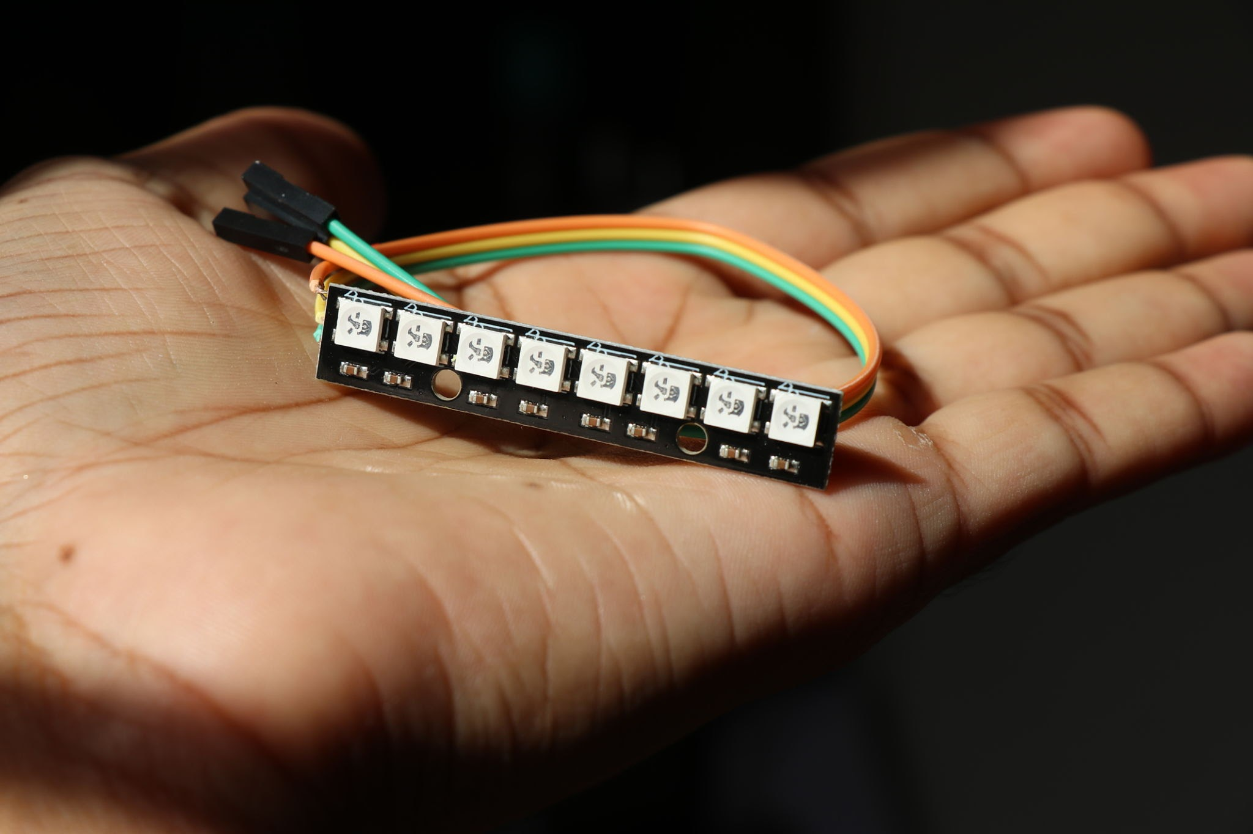
Addressable WS2812B RGB module. Source: Jeevan GB / Getty Images
Required Components
- Addressable LEDs: Buy WS2812B or NeoPixel LED light strands/bulbs. Standard LEDs won't work easily because addressable LEDs carry internal microcontrollers to let you address each bulb individually over a single data wire.
- Controller Board:
  - Option A (Pure C/C++): Arduino Uno/Nano or ESP32.
  - Option B (Linux): Raspberry Pi (runs full Linux OS, lets you run C/Python scripts natively).
- 5V Power Supply: An external 5V power adapter (LEDs draw significant current when bright).
- USB Cable & Jumper Wires: To connect the controller board to your laptop and components.
How to Inject Language Logic from Your Laptop
You do not run the program continuously on your laptop while it sends individual light signals over wires. Instead, you write the C/C++ code on your laptop, compile it, and flash (upload) it onto the board. Once uploaded, the board runs the code automatically whenever powered on.
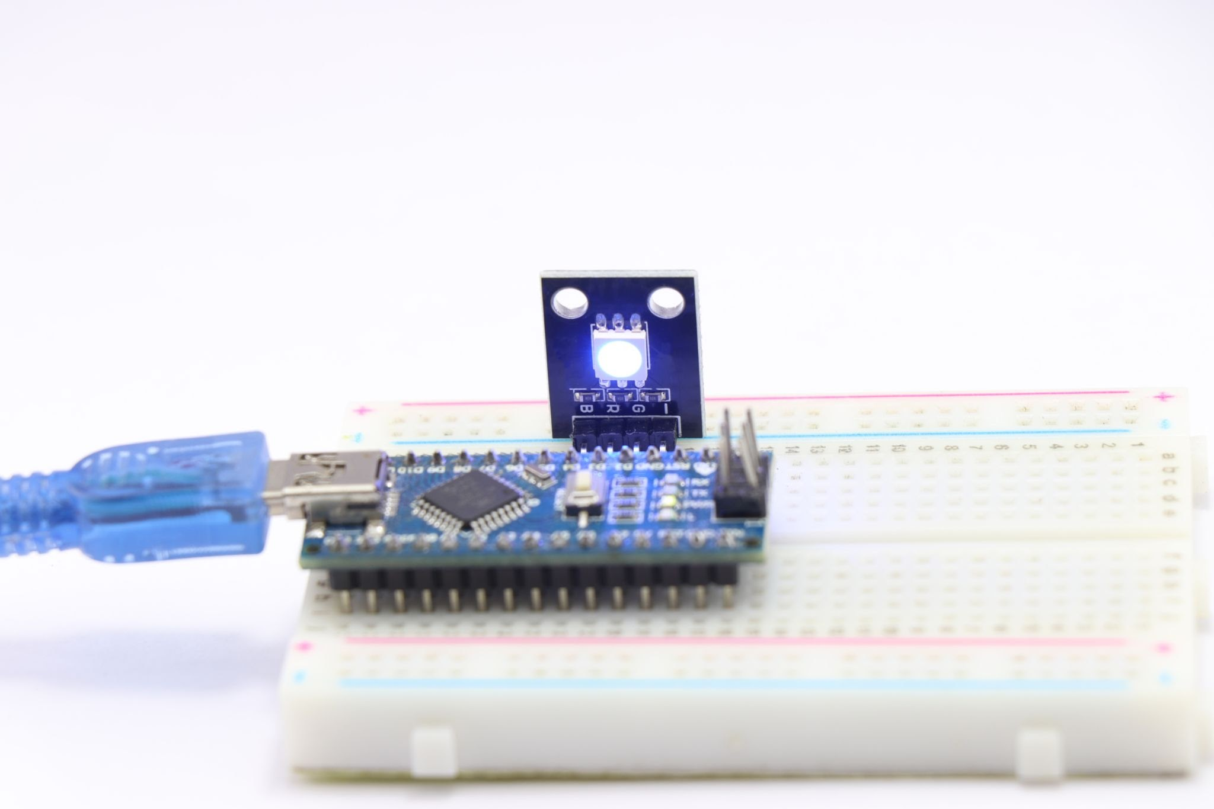
Flashing code from laptop to board. Source: Jeevan GB / Getty Images
How the Process Works
- Connect your controller (e.g., Arduino) to your laptop via USB.
- Install Arduino IDE (or VS Code with PlatformIO) on your laptop.
- Write C code using a library like FastLED or Adafruit NeoPixel to generate random 0–255 values for Red, Green, and Blue.
- Click Upload in the IDE. Your laptop compiles the C code into binary and transfers it over USB to the board's flash memory.
- Disconnect your laptop; the controller board now runs independently.
Sample C Code Logic
C++
#include <Adafruit_NeoPixel.h>

#define LED_PIN 6 // Data pin connected to LEDs
#define NUM_LEDS 10 // Number of bulbs in your series

Adafruit_NeoPixel strip(NUM_LEDS, LED_PIN, NEO_GRB + NEO_KHZ800);

void setup() {
strip.begin();
randomSeed(analogRead(0)); // Seed random generator
}

void loop() {
for(int i = 0; i < NUM_LEDS; i++) {
uint8_t r = random(0, 256); // 0 to 255 max
uint8_t g = random(0, 256);
uint8_t b = random(0, 256);

strip.setPixelColor(i, strip.Color(r, g, b)); // Set RGB for bulb i
}
strip.show(); // Update all bulbs
delay(1000); // Change colors every second
}
But I am in India. Is this readily available? and specially in tier 2 city like Baroda?
Yes, these components are readily available in India, and getting them in a Tier 2 city like Vadodara (Baroda) is quite straightforward.
While you might not find addressable LED strips at a standard local electrical shop in a neighborhood market, you have two very reliable ways to source them:
1. Dedicated Indian Hobbyist E-Commerce (Recommended)
India has a thriving online ecosystem for DIY electronics and maker components that ship directly to Vadodara within 3 to 5 days. Popular and trusted platforms include:
Zbotic
- Robu.in (One of the largest for Arduino, ESP32, and WS2812B strips)
Zbotic
- ElectronicsComp.com
- Quartzcomponents.com
- Probots.co.in
Probots
- Amazon.in (Often carries kits with Arduino and NeoPixels bundled together)
You can easily order a starter bundle containing an Arduino (Uno or Nano), a meter of WS2812B LEDs, jumper wires, and a 5V power adapter delivered right to your doorstep in Baroda.
2. Local Sourcing in Vadodara
If you prefer picking them up locally:
- There are embedded systems and engineering project labs/suppliers in Vadodara (such as local tech hobby stores, or vendors catering to engineering college projects, often found listed via platforms like Justdial or IndiaMART around areas dealing in industrial automation and electronics).
Justdial
- However, for standard hobby parts like WS2812B strips and microcontrollers, online stores are usually cheaper, offer a wider variety, and save you the trouble of traveling across the city.
But how self control logic in Cor linux is injected using laptop?
Injecting your custom C or Linux code into a microcontroller or single-board computer from your laptop works through one of two main hardware workflows: the Microcontroller (Bare-Metal C) approach or the Linux Single-Board Computer (Embedded Linux) approach.
Method 1: Microcontroller Approach (Arduino / ESP32 with C/C++)
In this method, there is no operating system. Your laptop compiles your C code into executable machine code (a .hex or .bin file) and pushes it directly into the chip's internal flash memory.
1
Connect Hardware
USB cable only
Connect your controller board (e.g., Arduino Uno or ESP32) to your laptop using a standard USB cable. The laptop provides both power and data lines to the board.
2
Write Code on Laptop
Open an IDE (such as Arduino IDE or VS Code with PlatformIO) on your laptop. Write your C logic containing the random RGB generation functions and LED controls.
3
Compile & Upload (Flash)
Click Upload in the IDE. Your laptop performs two tasks under the hood:
- Compiler: Translates your C source code into raw binary code designed specifically for the chip's architecture.
- Flashing Program (e.g., avrdude or esptool): Sends the compiled binary file over the USB-to-Serial converter chip on the board, overwriting the chip's flash memory with your new logic.
4
Standalone Execution
Once flashing is complete, disconnect the board from your laptop. When you connect a 5V power supply to the board, it starts running your C loop autonomously from step zero every time it boots.
Method 2: Embedded Linux Approach (Raspberry Pi)
If you use a board running full Linux (like a Raspberry Pi), the board operates like a tiny computer. You don't "flash" the hardware memory directly; instead, you write a standard C program or script and run it inside the Linux environment.
Connection Method | How It Works | Best Used For
Direct Monitor & Keyboard | Plug a HDMI monitor, keyboard, and mouse into the Pi. Open the terminal, compile your C code using gcc, and execute it locally. | Initial setup and visual testing.
SSH (Secure Shell) over Wi-Fi/Ethernet | Connect both your laptop and Pi to the same network. Open the terminal on your laptop and log into the Pi remotely (ssh pi@raspberrypi.local). | Remote development without extra monitors.
SFTP / VS Code Remote Extension | Write C code directly inside VS Code on your laptop; it syncs files to the Pi automatically in the background over Wi-Fi. | Smooth development workflow.
How the Linux Code Executes the Logic
On an embedded Linux setup:
- You compile your code directly on the Pi or cross-compile it on your laptop:
Bash
gcc -o led_control main.c -lpigpio
- You configure Linux to run your compiled program automatically at startup by adding your binary executable to systemd service manager (/etc/systemd/system/led_control.service) or crontab:
Bash
@reboot /home/pi/led_control
- Once configured, the Linux OS boots up, automatically triggers your C binary background process, and controls the pins feeding your LED series without any connection to your laptop.
Can simple bulbs with independent chips can be used?
No, standard individual light bulbs (like regular household AC bulbs or simple 2-wire DC bulbs with built-in internal flashing chips) cannot be used for this.
Simple off-the-shelf bulbs with built-in chips operate on fixed, pre-programmed internal patterns. They lack an external data pin, meaning you have no way to program, inject custom logic, or sync RGB scales (0–255) into them from a laptop or controller.
To get full control over each bulb individually, you need specific types of components:
Component Type | Independent Chips Built-In? | Programmable RGB (0–255)? | How Control Works
Addressable LED Nodes / Pixels (e.g., WS2812B / UCS1903) | Yes | Yes | Each bulb has an integrated driver IC inside. A single data wire passes signals from your controller to each bulb's chip in series.
DMX512 RGB Bulbs | Yes | Yes | Commercial stage bulbs with internal chips that receive color values over a DMX serial protocol line.
Auto-Flashing RGB LEDs (2-Pin) | Yes | No | Has a chip inside, but cycles colors on a fixed internal timer automatically when powered. No external control line.
Standard 2-Wire DC/AC Bulbs | No | No | Purely passive lighting. Only turns on/off based on power input.
Your Options for a "Bulb" Form Factor
If you want the visual look of physical light bulbs (rather than a flat LED ribbon/strip), you can buy addressable LEDs packaged inside bulb-shaped casings:
- WS2811 / WS2812 12mm Bullet Pixels: Individual sealed nodes shaped like mini-bulbs, commonly used for outdoor displays and festive light strings. Each node has an independent chip inside driven by your laptop's uploaded C code.
- 5V WS2812B Module Boards: Small round circuit boards featuring an addressable RGB chip. You can mount decorative bulb-shaped plastic diffusers over them.
- Custom Relay Circuitry (Standard Bulbs): If you insistence on using traditional 230V household light bulbs, you cannot use chips inside the bulbs. Instead, you keep the bulbs basic and control them externally using a multi-channel Relay Module or MOSFET driver board connected to your Arduino/Raspberry Pi.
Want to see how WS2811 Bullet Pixels look and wire up?
Yes
This is preferable:

If you want the visual look of physical light bulbs (rather than a flat LED ribbon/strip), you can buy addressable LEDs packaged inside bulb-shaped casings:

But how compiled program will be injected in circuit and source code? Will it be done in lunux or C?
To understand how the logic is injected into the circuit, you first need to understand the division of labor between your Laptop, your Controller Board (e.g., Arduino), and the Bullet Pixels.
You do not program the bullet light bulbs directly. Instead, you program a central controller board, which continuously sends electrical timing signals down a single data wire to control every individual bulb's internal WS2811 chip.
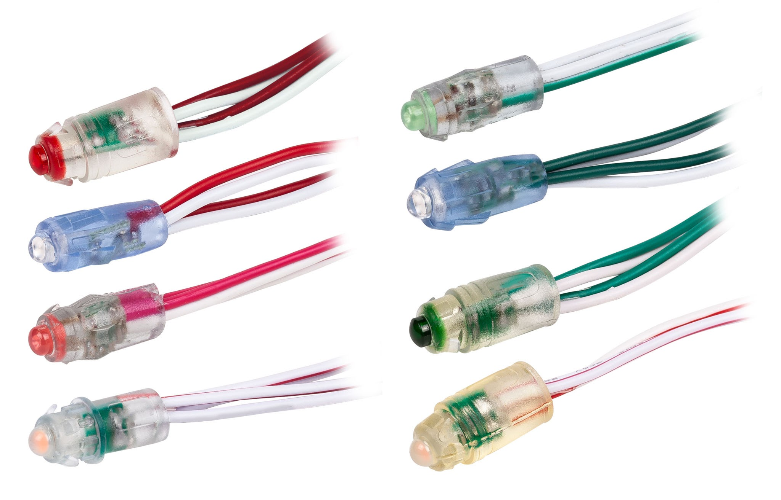
WS2811 bullet pixel nodes. Source: Nikita Rublev / Getty Images
Is it done in C or Linux?
It is primarily done in C (or C++).
- Language (C/C++): You write the source code containing your random RGB mixing logic in C/C++. Microcontrollers do not need a Linux operating system to run simple light loops; C code runs directly on the "bare metal" processor.
- Operating System (Linux): You can use a Linux laptop (or Windows/macOS) to write the C code and compile it. Linux acts purely as your development workbench.
How the Compiled Program is Injected into the Circuit
The transfer process does not happen over the air or directly into the lights; it moves from software on your laptop to physical hardware via USB.
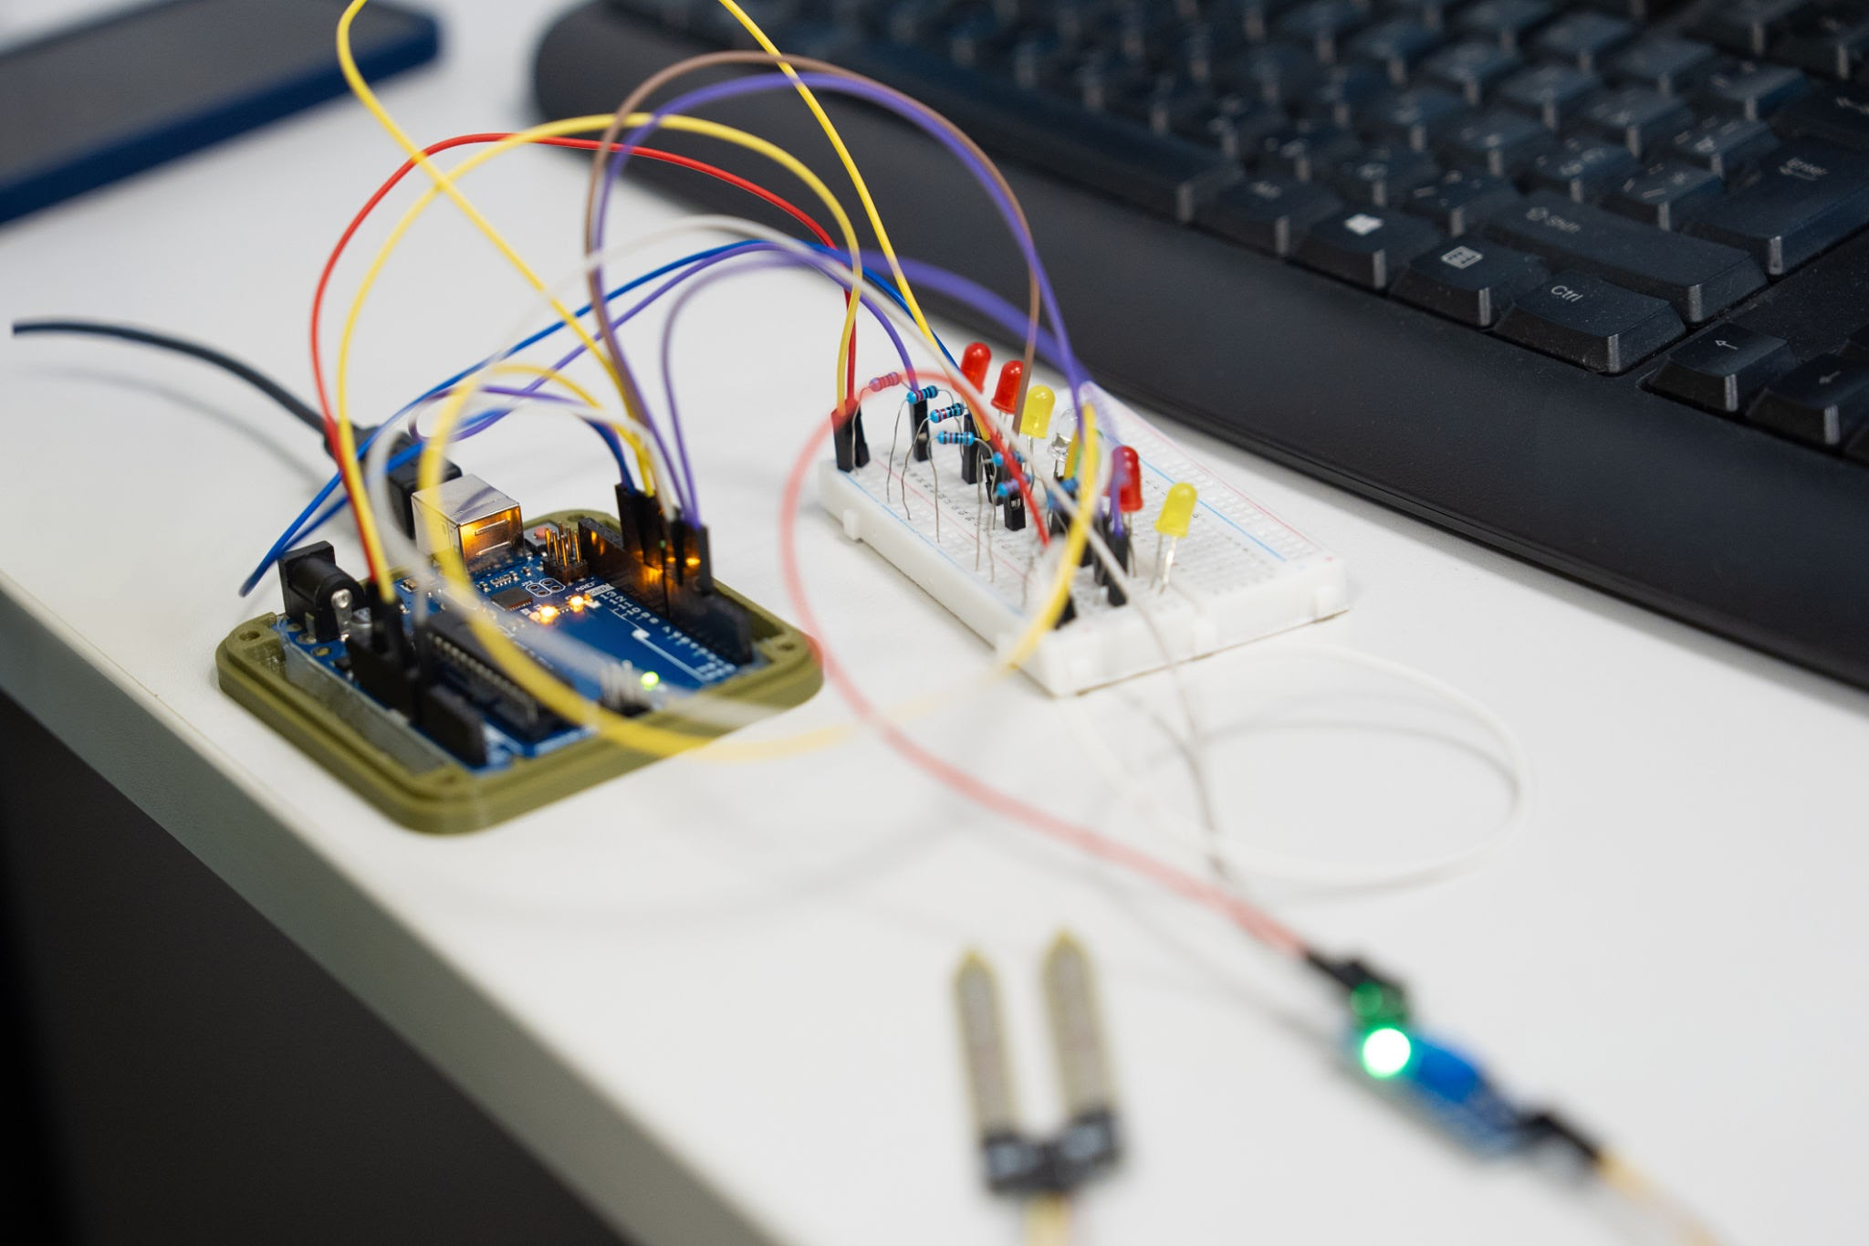
Uploading compiled logic via USB. Source: Tsyb_Oleg / Getty Images
1
1. Write Source Code
Writing the logic in C
On your laptop, you write the C program. You use a math function like rand() % 256 to pick random numbers between 0 and 255 for Red, Green, and Blue for each bulb index.
2
2. Compile Code
Laptop transforms text to binary
When you click Compile (using software like the Arduino IDE or GCC toolchain), a compiler program on your laptop translates your human-readable C text file into a raw binary machine code file (.hex or .bin).
3
3. Inject (Flash) the Hardware
USB data transfer
Your laptop connects to the controller board (Arduino) using a standard USB cable. The laptop software uses a flash utility (like avrdude) to push that binary file down the USB line and write it permanently into the controller board's on-board flash memory chip.
4
4. Signal Generation to Bullets
Circuit execution
Once flashed, the USB cable can be removed. The controller board boots up, reads the binary program from its memory, and starts executing your C loop:
- It calculates 3 random numbers (e.g., Bulb 1 = R:120, G:45, B:255).
- It pulses electrical high/low voltage signals down the Data Input (DIN) wire connected to the string of WS2811 bullet pixels.
- The small microchip inside Bulb 1 captures its RGB instruction, passes the rest of the signal to Bulb 2, and displays your custom color mix.
How do I compile and flash Arduino C code to a controller board using command line tools in Linux?
The modern tool for managing, compiling, and flashing Arduino code entirely from the Linux terminal is arduino-cli. It packages the official compilation toolchain into a single command-line interface.
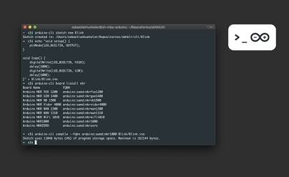
Arduino CLI terminal workflow. Source: Arduino
Step 1: Install arduino-cli
Run the official installation script or install it via your package manager:
Bash
curl -fsSL https://raw.githubusercontent.com/arduino/arduino-cli/master/install.sh | sh
Add it to your PATH (or move the binary to /usr/local/bin):
Bash
sudo mv bin/arduino-cli /usr/local/bin/
Initialize the configuration:
Bash
arduino-cli config init
Step 2: Install Core Platforms & Libraries
Update the board index and install the core for your controller board (e.g., standard AVR boards like Arduino Uno/Nano):
Bash
# Update board index
arduino-cli core update-index

# Install AVR board core package
arduino-cli core install arduino:avr

# Install the library required for addressable LED bulbs
arduino-cli lib install "Adafruit NeoPixel"
Step 3: Create Your Sketch & C Code
Create a new sketch directory and file:
Bash
arduino-cli sketch new RandomLEDs
cd RandomLEDs
Open RandomLEDs.ino in your terminal editor (vim, nano, or micro) and paste your C/C++ code:
C++
#include <Adafruit_NeoPixel.h>

#define LED_PIN 6
#define NUM_LEDS 10

Adafruit_NeoPixel strip(NUM_LEDS, LED_PIN, NEO_KHZ800 + NEO_GRB);

void setup() {
strip.begin();
strip.show();
randomSeed(analogRead(0));
}

void loop() {
for (int i = 0; i < NUM_LEDS; i++) {
strip.setPixelColor(i, strip.Color(random(256), random(256), random(256)));
}
strip.show();
delay(1000);
}
Step 4: Identify the Connected Port & FQBN
Plug your controller board into your laptop via USB and list connected devices:
Bash
arduino-cli board list
Note the Port (e.g., /dev/ttyACM0 or /dev/ttyUSB0) and the FQBN (Fully Qualified Board Name, e.g., arduino:avr:uno).
Linux Serial Permission Note: Ensure your user account belongs to the dialout or uucp group so you have permission to write to serial ports:
Bash
sudo usermod -aG dialout $USER
Step 5: Compile & Flash (Upload)
- Compile the source code into binary:
Bash
arduino-cli compile --fqbn arduino:avr:uno .
- Upload the compiled binary to the board:
Bash
arduino-cli upload -p /dev/ttyACM0 --fqbn arduino:avr:uno .
Alternatively, combine both steps in a single line:
Bash
arduino-cli compile --upload -p /dev/ttyACM0 --fqbn arduino:avr:uno .
Once uploaded, the board starts executing the compiled C logic immediately and continues running standard standalone power.

Edit Image
But this will require many accessories like shouldering iron with wire which melts and fuses the cables to the circuit board, etc. will I get all these components bundled online?
You do not need a soldering iron to build this project.
If you prefer to avoid soldering (which involves melting solder wire to fuse connections), you can build the entire setup using completely solderless, plug-and-play components that snap together using pre-wired connectors and breadboards.
Solderless vs. Soldered Setup
Component | Solderless Approach (Recommended) | Soldered Approach
Board Connections | Plug DuPont Jumper Wires into an Arduino Uno or Breadboard. | Solder bare wires onto an Arduino Nano.
Bullet LED Pixels | Buy WS2811 Bullet Strings pre-equipped with JST-SM 3-Pin Connectors. | Solder individual wires to bare LED contacts.
Power Supply | Screw bare wires into a DC Barrel Jack Terminal Adapter. | Solder power wires directly to the board.
Required Tools | Only a small flathead screwdriver. | Soldering iron, solder wire, flux, and stand.
Solderless Hardware List & Availability
Every component listed below is readily available online in India through e-commerce stores (such as Robu.in, ElectronicsComp.com, Amazon.in, or JioMart):
- WS2811 12mm Bullet LED String (5V): These come pre-wired as a string of bullet-shaped bulbs. They include factory-molded 3-pin JST connectors on both ends. You just plug them together without stripping or melting wires.
Probots
- JST-SM 3-Pin Extension Cables: Pre-crimped wire pigtails that plug directly into the LED string's data line.
Probots
- Arduino Uno R3 (DIP Version): Unlike tiny microcontroller chips, the standard Arduino Uno features female header sockets built right onto the board. You simply push jumper pins directly into the slots (Pin 6 for Data, GND for Ground).
- Breadboard & Male-to-Female Jumper Wires: Push-fit wires that allow you to route connections between the Arduino and power lines by pushing metal pins into plastic slots.
- 5V 2A Power Adapter + Screw Terminal DC Jack: A power adapter with a standard barrel jack plugs into a female terminal connector. You insert stripped wire ends into small slots and tighten them with a screwdriver to secure power without soldering.
Solderless Wiring Layout
[ 5V Power Adapter ]
│
├── (+) Wire ───► WS2811 Red Wire (Power)
│
└── (-) Wire ──┬──► WS2811 White/Black Wire (Ground)
│
└──► Arduino GND Pin (Common Ground)

[ Arduino Uno ]
│
└── Pin 6 ────────► WS2811 Green Wire (Data Input)
Available Components & Basic Soldering Kits
If you ever wish to try soldering, basic 60W temperature-controlled soldering iron kits (including solder wire, stand, and flux) are available online for under ₹1,000. However, for this project, choosing WS2811 bullet strings with JST connectors paired with an Arduino Uno completely eliminates the need for soldering tools.
Probots
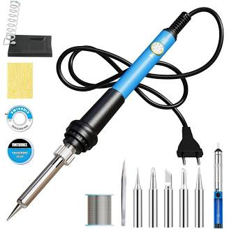
Soldering Iron Kit, 60W Soldering Iron Adjustable Temperature Set, Solder Wire, Stand, Rosin Paste Flux, Sponge, Fast Heating, Desoldering Electronic
₹899.00
An affordable beginner soldering iron set with temperature control, including solder wire, flux, and stand.
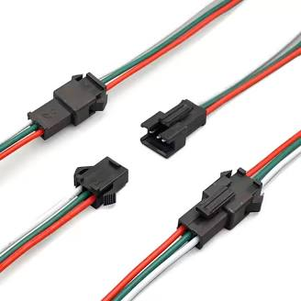
AURECIS 10 Pair 3 Pin JST Male Female Plug Pixel LED Connector Cable 15cm 22awg Wire for WS2812B WS2812 WS2811 SK6812 SK6812-RGBW LED Strip Light
₹219.00·Jst
4.9(422)
Plug-and-play 3-pin JST connector pairs allow solderless wire extensions for WS2811 addressable LED light strings.
Probots
Would you like a solderless shopping checklist for this project?
Yes
Soldering seem outdated or is it still a preferred method?
Soldering is far from outdated—it remains the industry gold standard for building permanent, reliable electrical connections.
While solderless methods (like breadboards and jumper wires) are great for temporary experiments on your workbench, soldering is required whenever a project moves into real-world use.
Why Soldering is Still Preferred
Factor | Solderless (Jumper Wires / Breadboards) | Soldered Connections
Primary Use | Prototyping, testing code, temporary setups. | Final products, permanent installations, high-reliability gear.
Mechanical Strength | Weak: Wires easily pop out if bumped or pulled. | Permanent: Fuses metals together into a single rigid joint.
Electrical Contact | Frictional: Susceptible to oxidation, loose fits, and intermittent power cuts. | Atomic bond: Low resistance, highly consistent current flow.
Vibration & Wear | Fails quickly under movement or outdoor stress. | Handles physical movement, strain, and environmental changes.
Current Capacity | Limited (thin pins overheat under high LED current). | Higher amperage limits without loose wire spark risks.
Why You Can Skip It For Now
For your LED project, you don't need to solder on day one. Using pre-crimped JST connectors and an Arduino Uno with female headers lets you verify your random RGB C logic and test everything safely without buying extra tools.
Once your C program works and you decide to mount those bullet bulbs permanently around a room or frame, soldering the power and data joints ensures the lights won't flicker or lose power over time.
Want to know the essential tools for a basic electronics workbench?
Yes
But I am looking at real worls use - coming Diwali festival.
For a real-world outdoor holiday display, soldering combined with proper weatherproofing is the absolute gold standard.
While push-in jumper wires work for testing on your desk, Diwali outdoor setups face high humidity, temperature changes, and wind pull. Unsoldered push-in pins can corrode, vibrate loose, or short out mid-festival.
Why Soldering is Essential for Outdoor Diwali Lights
- Weatherproofing (Rain & Dew): Soldered joints wrapped in adhesive heat shrink tubing are 100% sealed against water ingress.
- Current Draw: 50+ LED pixels drawing several amps of current will cause push-fit jumper wires to heat up and loose voltage, making distant bulbs look dim or misbehave.
- Tensile Strength: When stringing lights along a balcony or wall, soldered wires won't disconnect if pulled by wind or during setup.
Hardware Needed for a Real-World Outdoor Setup
To build a reliable outdoor string, you need to step up from breadboards to an industrial power supply and robust soldered connections:
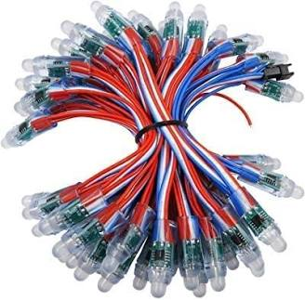
50 Bulb Pixel LED 100% Coper Original Chain Multicolor String Light WS2811 Addressable RGB LED String Lights Waterproof 12mm (5V DC 50 PCS)
₹599.00
IP68 waterproof WS2811 bullet LED string suited for outdoor holiday decor, individually controlled per node.
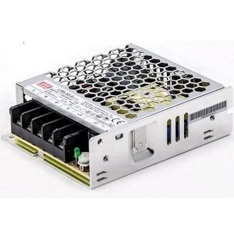
Mean Well LRS-50-5 SMPS Power Supply – 5V 10A 50W Metal Case | Reliable DC Power Adapter
₹1,266.00·MEAN WELL
4.9(12)
An industrial 5V SMPS metal-case power supply capable of providing clean power for 50–100 addressable LED bulbs running at peak brightness.

Soldering Iron Kit Soldering Gun Soldering Iron 60W Adjustable Temperature
₹439.00
4.8(44)
A basic 60W adjustable soldering kit with wire, stand, and flux to make low-resistance joints.
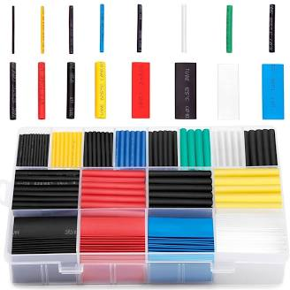
580PCS Heat Shrink Tubing Kit – Assorted Colored Electrical Wire Cable Insulation Sleeves – Waterproof Flame Retardant Polyolefin Wrap – Multiple
₹399.00
Flame-retardant heat-shrink insulation sleeves to seal soldered wire joints tightly against moisture and short circuits.
Standard Outdoor Wiring Workflow
- Solder the Connections: Solder the Data (Pin 6) and Ground (GND) lines from your Arduino directly to the input end of your WS2811 bullet string.
- Inject Power: Connect the 5V industrial SMPS supply terminals (+V and -V) directly to the power wires on the LED string using thick copper gauge wires.
- Seal with Heat Shrink: Slide a piece of heat shrink sleeve over the joint before soldering, slide it over the finished joint, and shrink it tight using a lighter or heat gun.
- Enclose the Controller: Keep the Arduino board and power supply inside a weatherproof plastic junction box, running only the waterproof LED string outdoors.
Would you like a full outdoor schematic and power injection guide for 50+ bulbs?

